Project Design Phase-II
AI FitTrack – Technology Stack (Modern Architecture & Stack)
Date | 24 September 2026
Team ID | AI-FITTRACK-TEAM
Project Name | AI FitTrack – AI-Powered Fitness Tracking System
Maximum Marks | 4 Marks
Technical Architecture:
The deliverable shall document the modern React + Express + MongoDB Atlas + Gemini architecture and the technology choices in Table-1 and Table-2.
Project Context: secure AI-powered fitness tracking with authenticated workout management and AI-assisted recommendations.
Guidelines:
Include all the processes (As an application logic / Technology Block)
Provide infrastructural demarcation (Local / Cloud)
Indicate external interfaces (third party API’s etc.)
Indicate Data Storage components / services
Indicate interface to machine learning models (if applicable)

Table-1 : Components & Technologies:
S.No | Component | Description | Technology
1 | User Interface | Web client used for authentication, workout tracking, dashboard and AI interaction. | React, Vite, HTML5, CSS3, JavaScript
2 | Application Logic-1 | REST API routing, validation and business logic. | Node.js, Express.js
3 | Application Logic-2 | Authentication and authorization. | JWT, bcryptjs
4 | Application Logic-3 | AI recommendation and fitness insight generation. | Google GenAI SDK / Gemini
5 | Database | User and workout persistence. | MongoDB, Mongoose
6 | Cloud Database | Managed cloud database for production-style development. | MongoDB Atlas
7 | File Storage | Environment configuration and local project assets. | Local filesystem / .env
8 | External API-1 | Generates personalized workout recommendations. | Google Gemini API
9 | External API-2 | Provides AI fitness insights from activity metrics. | Google Gemini API
10 | Machine Learning Model | Generative model for natural-language fitness guidance. | Configured Gemini model
11 | Infrastructure | Local development with cloud database and external AI service. | Windows + Node.js + MongoDB Atlas
Table-2: Application Characteristics:
S.No | Characteristics | Description | Technology
1 | Open-Source Frameworks | Documented frameworks and runtime used by the solution. | React, Express.js, Node.js, Mongoose
2 | Security Implementations | Authentication, password hashing, protected resources and security headers. | JWT, bcryptjs, Helmet, CORS, .env secrets
3 | Scalable Architecture | Layered MVC-style API separates routes, controllers, services and models. | Express MVC, modular services
4 | Availability | Managed MongoDB Atlas reduces dependency on local database availability. | MongoDB Atlas + application health endpoint
5 | Performance | Pagination, filtering, lean data access patterns and focused API endpoints reduce unnecessary work. | Express query parameters, MongoDB indexes/query filters
Modern Architecture Notes
The React client and Express API are independently runnable. The API exposes a stable REST contract so the UI can evolve without changing database responsibilities. MongoDB Atlas is the persistent store and Gemini is isolated behind a service layer.
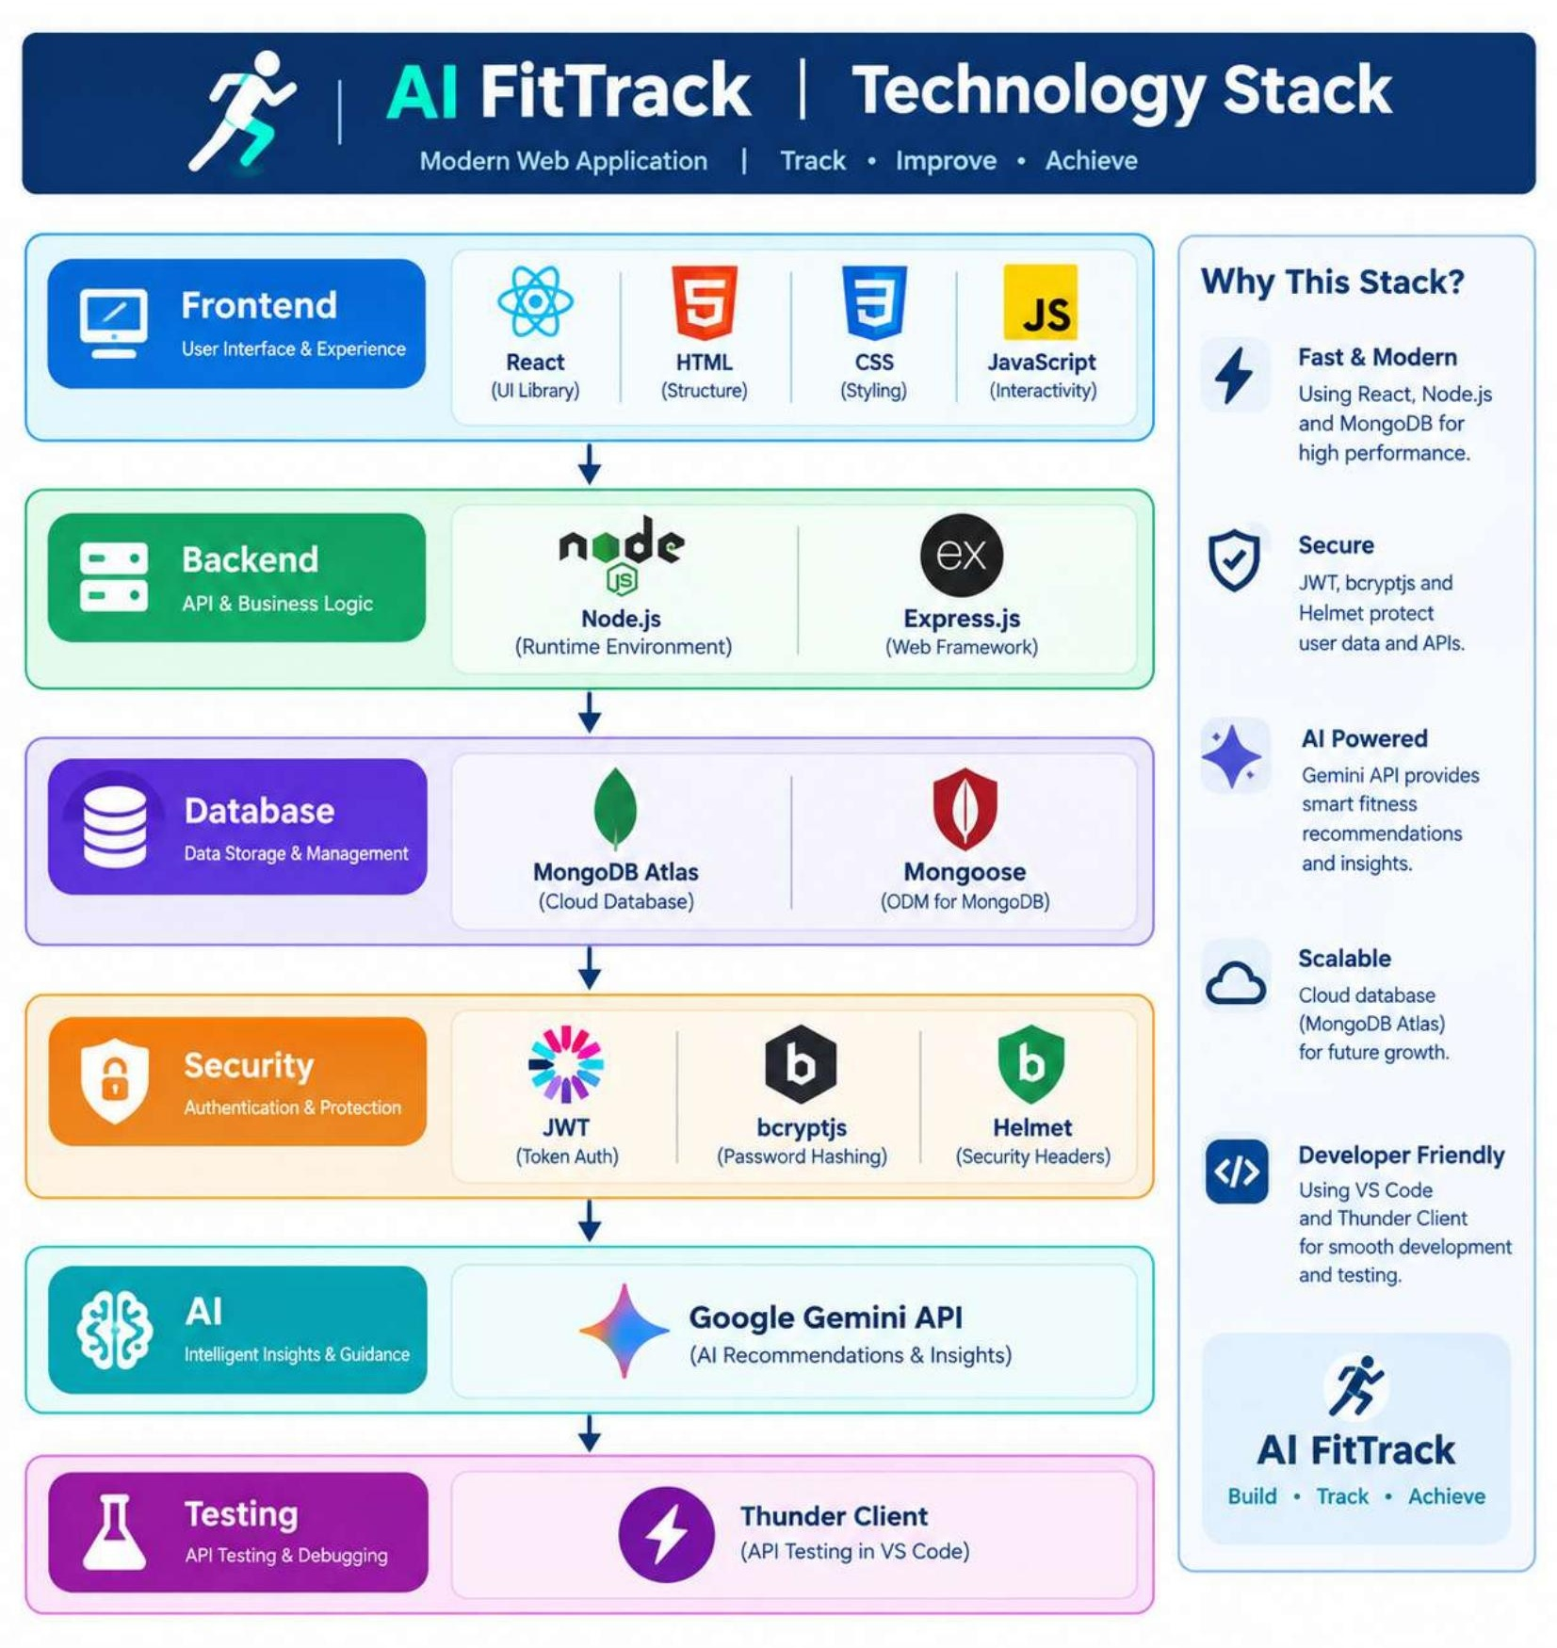
Development & Deployment Configuration
Backend default port: 5000. React development server: 5173. Environment variables include MONGO_URI, JWT_SECRET, GEMINI_API_KEY, GEMINI_MODEL and CLIENT_URL. Production deployment should use a secret manager rather than committing credentials.

